JAVA 3 Project Q1

30003389 – Kyer Potts

Table of Contents

Table of Contents i

Debugging 1

Test Case 2

Profiler 3

Server 3

Client 4

# Debugging

Disconnection process was not working, received errors from Server class

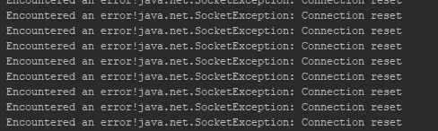

Fixed by adding if statement sending disconnection string



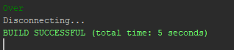

# Test Case

|  |  |  |  |
| --- | --- | --- | --- |
| Test ID | Description | Outcome | Evidence |
| 1 | Client connects to Server | Client Connects |  |
| 2 | Enter 5 | Produces 25 |  |
| 3 | Enter 18 | Produces 324 |  |
| 4 | Enter 255 | Produces 65025 |  |
| 5 | Enter Over | Disconnects |  |

# Profiler

### Server

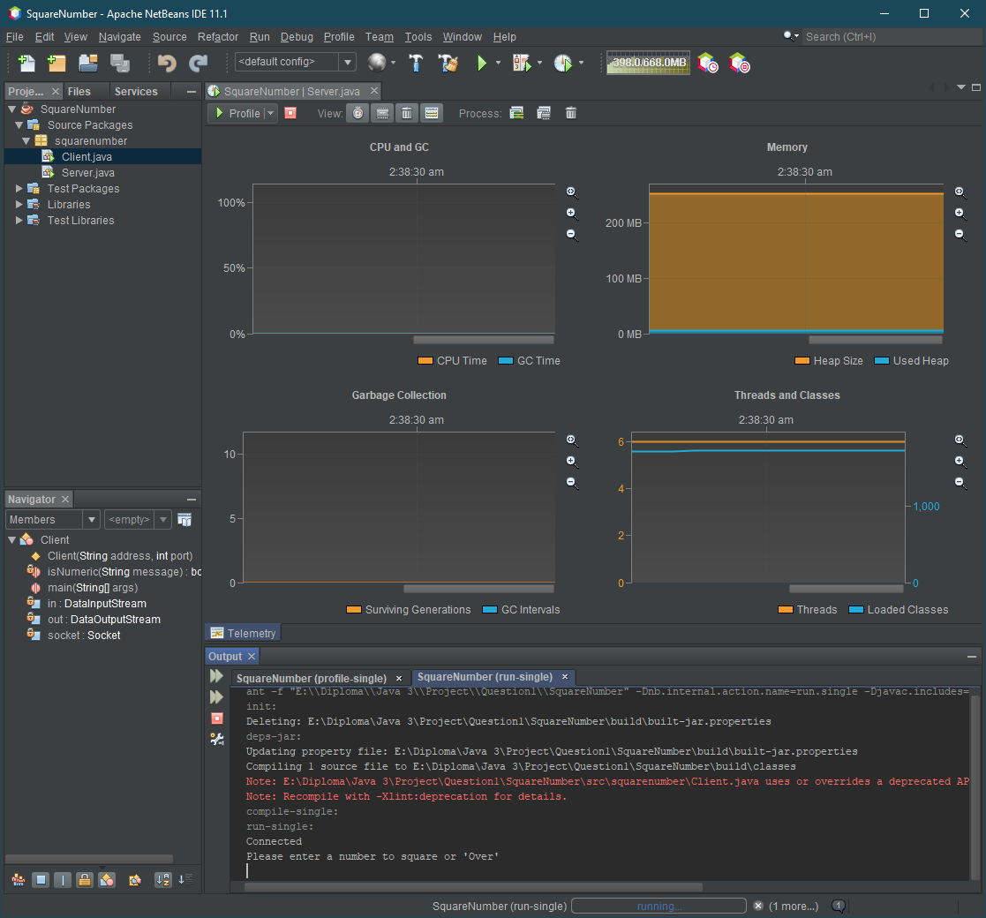

### Client

